REGULAR *DEEPDIVE* KNOWLEDGE

First of all, our **challenge statement** is “How might we effectively integrate folding-bikes-systems and rail usage in urban and rural areas?”

*Deutsche Bahn Connect* is a subsidiary of *Deutsche Bahn*. The main focus when looking at the site should be **on bike sharing** **offering – *Call a Bike***.

|  |  |  |
| --- | --- | --- |
| **Customers of *Deutsche Bahn Connect*** | | |
| **Cities & Municipalities** | **B2B Corporations** | **Private Users** |
| Customized bikesharing systems | Supply of corporate bikesharing systems for employees (for the way to work / a business trip) | Self-operating bikesharing fleets, various small stationary Systems |

„We are experimenting for two reasons: first of all, space is getting scarcer, especially in stations, so it’s harder and harder to get parking slots, even for bikes. And second, it’s harder and tougher to find bike spaces within our trains, however, our customers <…> are really expecting opportunities to travel with their bike and to really come up with an interlinked travel chain or an intermodal travel experience. <…> the question is how could we go beyond *(this bike*), <…> not only in city centers, but also providing solutions for suburban areas?“

*Deutsche Bahn Connect* teamed up with *Brompton Bikes* – UK folding-bikes manufacturer and bike operator of bike-sharing schemes.

*DEUTSCHE BAHN CONNECT*

|  |  |  |  |
| --- | --- | --- | --- |
|  | **PRIVATE** | **PUBLIC** | **BUSINESS** |
| **Slogan** | *Move sustainably* | *Develop your city* | *Share in the success* |
| **What is offering** | * carsharing (*Flinkster* – from family cars to electric cars and business sedans); * bikesharing (*Call a Bike* is an ideal add-on to travel by train); * local public transport (S-Bahn and U-Bahn trains) | carsharing and bikesharing products | DB Connect's range of services |
| **Products** | * *Call a Bike* – a bikesharing system. * *Flinkster* – the carsharing network. | | |
| * *Long-term vehicle rental.* * *Bonvoyo* – the mobile benefit for employees (planning, booking and management of all journeys is handled via one single app). |  | * *Long-term vehicle rental.* * *Bonvoyo* – the mobile benefit for employees (planning, booking and management of all journeys is handled via one single app). |

|  |  |  |  |
| --- | --- | --- | --- |
|  | **PRIVATE** | **PUBLIC** | **BUSINESS** |
| **Pricing** | Base rate (for Calling a Bike occasionally):   * **EUR 3.00** / year (base fee) * **EUR 1.00** / 30 minutes * **EUR 1.00** for every additional 30 minutes * up to a maximum of **EUR 15.00** per 24 hours   Comfort rate (for hiring the bikes on a regular basis):   * **EUR 49.00** / year (base rate) * **free of charge** for 30 minutes * **EUR 1.00** for each additional 30 minutes * up to a maximum of **EUR 12.00** for 24 hours |  | Mobility bonus for employees:   * Starting at **EUR 6.00 per person per year** – round the clock access to Call a Bike bikes for all employees * 30 minutes of every trip are **free of charge**   The bike station for your company (if requested) + daily restocking service (optional)  Bike mobility for students:   * the first 60 minutes of every trip are **free of charge** |

DESK RESEARCH

[Folding Bicycles: A Treatise](https://www.cykelportalen.dk/wp-content/uploads/2016/10/free-download-Folding-Bicycles-A-Treatise.pdf)

“A Folding Bicycle is defined as a two-wheeled vehicle, with pedals, which can be folded up or otherwise reduced into a more manageable shape / size package or set of packages for ease of storage or portage. That includes **take-apart bikes**. Some Folding Bicycles are also **electrically empowered (Folding E-Bicycle)**.”

“Most Folding Bicycles have small wheels for compactness, but this is more or less at the expense of comfort and performance, if not safety.”

“**The majority of Folding Bicycles today are built of either steel or aluminum alloy**, <…> due to its inherent advantages and general cost reduction.”

[The design of a composite folding bike to improve the user experience of commuters](https://www.matec-conferences.org/articles/matecconf/pdf/2018/26/matecconf_ic4m-icdes2018_01001.pdf)

“The first main deficiency is the **complexity of the folding mechanisms with safety locks**. <…> In addition, the need for skilled and precise handling leads to **a bike** that **does not fold fast and easy enough** for the rushed daily use while commuting. A second important drawback is that **most folding bikes are chunky and too heavy**, making them uncomfortable and a big burden to carry. This is because they are made out of traditional bike-building materials, such as aluminum and steel alloys. A third flaw is the abundance of **exposed or poorly incorporated parts**, such as exposed brake cables or externally mounted lights and reflectors. These elements obstruct the ease of use. A last main weakness of folding bikes is **the small wheels**. Folding bikes often have 20” or even 16” wheels. This results in **a lack of comfort and even sketchy riding** characteristics, especially at higher speeds”

“… the current market offer still has several downsides, such as **the uncomfortable small wheel size** [8], **the oversized volume when folded and** their **excessive weight** [9].“

How can the ability to fold a bike faster when in a hurry be improved?

“An interesting study was conducted on the optimal direction of the pivot axis of the hinge of a folding bike [13]. An alternative was sought for the classic single lateral pivot type folding mechanism, which causes significant troubles in folding dimensions and the front and rear wheels end up arranged in a slanted way. The research **shows for the need of a folding mechanism that aligns both the front and rear wheel in parallel, which would result in excellent usability and smaller folding width**.”

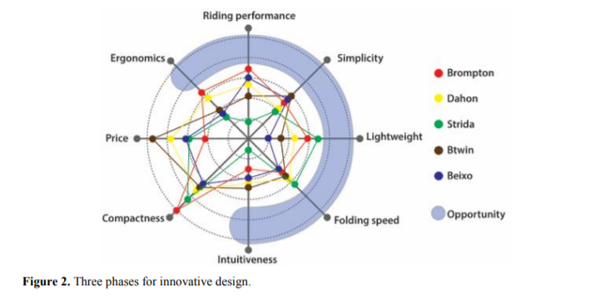

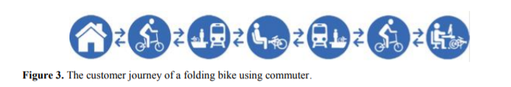

[The Intermodal Bike: multi-modal integration of cycling mobility through product and process innovations in bicycle design](https://content.iospress.com/download/work/wor0344?id=work%2Fwor0344)

“The paper presents the early results of the UE-FP7 project “The Intermodal Bike”. The research aim is **to provide a super-compactable, super-lightweight folding bicycle** as a realistic solution to graft the cycling mode onto the root of the public or private transportation systems.”

“We ran a survey through a multiple-choice questionnaire on a sample of experienced urban cyclists, found mainly through cyclist associations. In total, 200 respondents were experienced users of different age groups. According to the survey, **the folding bikes are considered lightweight and compact enough, but are still perceived by most consumers as strenuous, unreliable and unstable**.”

“Based on the posture of the identified 'ideal', or better than the optimal range of angles of joints involved in cycling, has been designed on the bicycle frame and therefore we have defined **an optimal “ergonomic triangle” (handlebar-seat-crank)** so as to make the experience of the ride comfortable for the higher percentile of users as possible.”

“An ideal bicycle has **a very stiff frame**, moving to accurately chosen areas, outside a closed “hard cell”, the desired elastic elements for comfort and suspension. This happens for instance in all **carbon-fiber modern frames**. <…> **the space-frame** is particularly suited to realize an opening-closing structure, as a collection of rods and cables, all very similar in length, lends itself to be packed in a very dense configuration, with a minimum of "air" in between, obtaining therefore a very compact pack.”

[Folding and Self-Propelling Bicycle](http://www.ijimt.org/papers/504-H1011.pdf)

“We decided to design **a bicycle that is self-propelling**. Also it can be folded when is needed. In this way it can be placed in a small bag.”

“We attempt to put four dynamos* inside the rear wheel and four ones in front wheel **for saving outcoming energy of rounding wheels. In this way we can keep this energy in its batteries**. When the man is going to be tired can change automatic mode by pressing a button. In this case a system transform 12w electric energy in batteries to 256w and push it to other dynamos that can transform electrical energy to a step motor (for lessen the wasted energy should to reduce the weight of the bike). This motor can adjust speed of our bike.”

* an electrical generator that produces direct current with the use of a commutator

[Integrating Bicycling and Public Transport in North America](https://digitalcommons.usf.edu/cgi/viewcontent.cgi?article=1191&context=jpt)

“There are five main categories of measures to promote bike-transit integration:

1. provision of bike parking at rail stations and bus stops, with different degrees of shelter and security

2. multi-functional bike stations providing not only parking but also a range of services such as bike rentals, repairs, parts and accessories, bike washing, showers and lockers, and touring advice

3. bike racks on buses, usually exterior, but occasionally interior storage

4. bikes on board vehicles, usually rail vehicles, sometimes with special bike racks, hooks, or even bike cars on trains

5. bike paths, lanes, and on-street routes that lead to public transport stations and stops, thus facilitating the bike’s role as feeders and collectors for public transport”

QUESTION RESEARCH

* **What** is the probability of the folding-bike system to break / malfunction? How quickly the malfunctions would be fixed (jumping gears, snapped chain, broken cleats or pedals)? Is it similar to fixing a regular bike or are there any differences?

[Brompton Bicycle Recalls Electric Folding Bicycles Due to Fall and Injury Hazards](https://www.cpsc.gov/Recalls/2021/Brompton-Bicycle-Recalls-Electric-Folding-Bicycles-Due-to-Fall-and-Injury-Hazards)

“Due to a software malfunction, the electric system can continue to provide assistance to the motor, causing continued forward momentum, when the rider is not actively pedaling, posing fall and injury hazards.” ([Brompton Bicycle Recalls Electric Folding Bicycles Due to Fall and Injury Hazards](https://www.cpsc.gov/Recalls/2021/Brompton-Bicycle-Recalls-Electric-Folding-Bicycles-Due-to-Fall-and-Injury-Hazards))

[Do Folding Bikes Break Easily?](https://ebikepursuits.com/do-folding-bikes-break-easily/)

“There is some truth that folding bikes have broken in half. Having a frame that collapses back on itself as many designs do, creates an obvious issue. <…> Both **the folding joint and the hinge have often been the weakest part of folding bikes**. Even when it comes to reputable brands, this is often still the case. The additional welding required also causes further weak points.”

“**How folding bikes are ridden also effects durability**. Most models come with a recommended maximum weight for a rider and guidelines. For example, most folding bikes aren’t meant to be ridden on heavy trails”

“Not many folding bikes break in half outright. Instead, **they will develop cracks or fractures in the hinge first**. Cracks can develop in any frame but occur more often with folding bikes around the hinge.”

* **How** can some kind of LCD screens (touchscreens) to, for example, show the route of bicycle ride, be integrated to foldable bikes? Would there be a risk of the screen breaking while accidentally folding the bike the wrong way? *(left unanswered → will put into the PADLET)*